

## **<<DNA BLOODLINE TESTING SERVICE MANAGEMENT SOFTWARE>> Project Report**

**Software Requirement Specification**

– Ho Chi Minh, July 2025 –

Table of Contents

I. Record of Changes 3

II. Software Requirement Specification 4

1. Product vision 4

2. Product Overview 4

3. User Requirements 5

3.1 Actors 5

3.2 Use Cases 5

4. Functional Requirements 5

4.1 System Functional Overview 5

5. Use case details 6

5.1 Login 6

5.2 Filter Transaction 8

6. Non-Functional Requirements 10

6.1 External Interfaces 10

6.2 Quality Attributes 10

7. Requirement Appendix 10

7.1 Business Rules 10

7.2 Common Requirements 11

7.3 Application Messages List 11

7.4 Other Requirements… 11

# I. Record of Changes

|  |  |  |  |
| --- | --- | --- | --- |
| **Date** | **A/M/D\*** | **In charge** | **Change Description** |
| 2025-07-15 | A | Trần Võ Quang Duy | Created the SRS document structure, defined system goals and target users. |
| 2025-07-17 | A | Võ Minh Ý | Analyzed actors and overview use cases; identified system users. |
| 2025-07-18 | A | Lý Gia Huy | Documented functional requirements of the system. |
| 2025-07-20 | A | Trần Hải Đăng | Wrote non-functional requirements (NFR), external interfaces, and system quality attributes. |
| 2025-07-22 | A | Trần Võ Quang Duy | Wrote detailed Use Cases from UC-01 to UC-05. |
| 2025-07-24 | A | Lý Gia Huy | Wrote detailed Use Cases from UC-06 to UC-10. |
| 2025-07-26 | A | Trần Hải Đăng | Wrote the Business Rules and Common Requirements section. |
| 2025-07-27 | M | Võ Minh Ý | Added “Mockup” row to each Use Case and adjusted table formatting. |
| 2025-07-28 | M | Trần Võ Quang Duy | Reviewed and revised the entire document; added Table of Contents. |

*A - Added M - Modified D - Deleted

# II. Software Requirement Specification

## 1. Product vision

**The Bloodline DNA Testing Service Management System** is a prototype digital platform developed by FPT University students with the goal of modernizing and simplifying the DNA testing service workflow in a healthcare context. While it may not meet all professional standards of commercial systems, it demonstrates the core functionalities required for managing both civil and administrative DNA testing services, supporting self-sample collection and in-facility procedures.

**Main users** include: medical facilities that offer DNA testing services, individual customers (in both civil and administrative contexts), and healthcare staff responsible for test management.

## 2. Product Overview

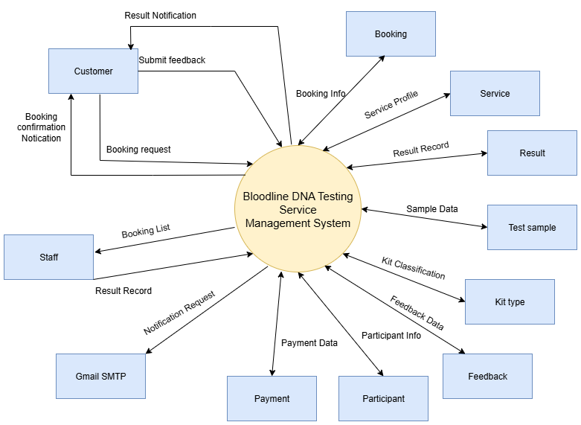

## 3. User Requirements

### 3.1 Actors

|  |  |  |
| --- | --- | --- |
| **#** | **Actor** | **Description** |
| 1 | **Guest** | A user who accesses the system without logging in. Guests can view public information such as the homepage, introduction, list of services, blog posts, and frequently asked questions (FAQs). |
| 2 | **Customer** | A registered user who can log in to the system. Customers can book DNA testing services (either in-facility or self-collection), view booking history, rate services. |
| 3 | **Staff** | Medical or lab personnel who can log in to manage DNA test results, confirm and monitor appointments, and ensure that sample collection and testing procedures are carried out accurately and on time. |
| 4 | **Manager** | A system manager responsible for overseeing overall operations. Managers can monitor customer feedback, service ratings, send warnings to staff if needed, update information on service packages, and view performance and revenue reports. |
| 5 | **Admin** | The system administrator with the highest level of control. Admins manage all user accounts (customers, staff, managers), handle violations, monitor system activity, and ensure the system remains stable, secure, and data is accurate. |

### 

### 3.2 Use Cases

#### 3.2.1 System Feature

### ****Feature 1: Book In-Facility Sample Collection****

**Description:**  
Allows users (no login required) to book an appointment to visit a medical facility for DNA sample collection. The system supports scheduling management and check-in/check-out at the facility.

**Functional Requirements:**

[F1.1] The user **books an appointment and selects the in-facility sample collection option**.

[F1.2] The system displays a form to input: full name, phone number, appointment time, test type, reason, etc.

[F1.3] After submitting the form, the system saves the appointment and shows a success message.

[F1.4] At the facility, staff members perform **check-in** when the user arrives and **check-out** after sample collection is completed.

[F1.5] Appointment history and status are updated in the system for staff to manage.

[F1.6] Once results are available, the user receives them via the contact method provided (email, phone).

### ****Feature 2: Book At-Home Sample Collection****

**Description:**  
Allows users to book an appointment for at-home sample collection. The system supports managing the delivery and return of test kits.

**Functional Requirements:**

[F2.1] The user **books an appointment and selects the at-home sample collection option**.

[F2.2] The system displays a form to input: full name, phone number, address for kit delivery, desired delivery time, test type, etc.

[F2.3] After submission, the system saves the appointment and forwards the information to the logistics team.

[F2.4] Staff **deliver the DNA test kit to the user's address** as scheduled.

[F2.5] After the user collects their sample, staff **retrieve the kit** for testing.

[F2.6] The system updates status at each stage: Kit Sent / Kit Received / Testing / Result Available.

[F2.7] Once results are ready, the user receives them via email or the contact method provided.

#### 3.2.2 Diagram(s)

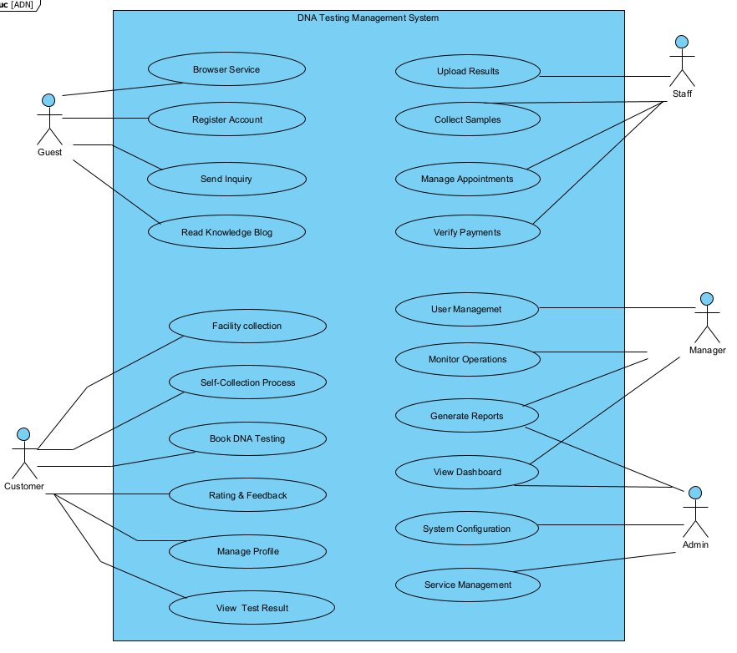

#### 3.2.3 Descriptions

|  |  |  |  |
| --- | --- | --- | --- |
| **ID** | **Use Case** | **Actors** | **Use Case Description** |
| UC-01 | Register | Guest | Guests create a new account using email and personal information. |
| UC-02 | Login | Guest, Customer, Staff, Admin | Users log into the system using valid email and password. |
| UC-03 | View Home Page | Guest | Guests access the homepage to see information about the organization and its DNA testing services. |
| UC-04 | View Blog | Guest | Guests view shared knowledge, testing guidance, and related blog posts. |
| UC-05 | View DNA Services | Guest, Customer | Users view the list of available DNA testing services and pricing. |
| UC-06 | Register DNA Test Appointment | Customer | Customer books an appointment for DNA testing, choosing method of sample collection. |
| UC-07 | Receive Test Kit | Customer | Customer receives the test kit by mail after booking home sampling service. |
| UC-08 | Submit Sample | Customer | Customer sends collected sample to the healthcare facility. |
| UC-09 | Sample Collection by Staff | Staff | Staff collects sample from customer (at home or clinic) and updates testing request. |
| UC-10 | Perform DNA Test | Staff, Consultant | Consultant performs DNA testing on received samples and records results. |
| UC-11 | View Test Result | Customer | Customer views test result securely on the system. |
| UC-12 | Manage DNA Services | Admin | Admin declares service types, pricing, and manages service availability. |
| UC-13 | Give Feedback & Rating | Customer | Customer submits ratings and feedback after receiving the test result. |
| UC-14 | Manage User Profiles | Customer, Admin | Customers update personal information; Admin manages user data. |
| UC-15 | View Test History | Customer | Customers review their past DNA test appointments and results. |
| UC-16 | Dashboard & Report | Admin, Manager | Admins and Managers view system performance reports and monitor activity. |

## 

## 4. Functional Requirements

### 4.1 System Functional Overview

#### 4.1.1 Screens Flow

**Guest**

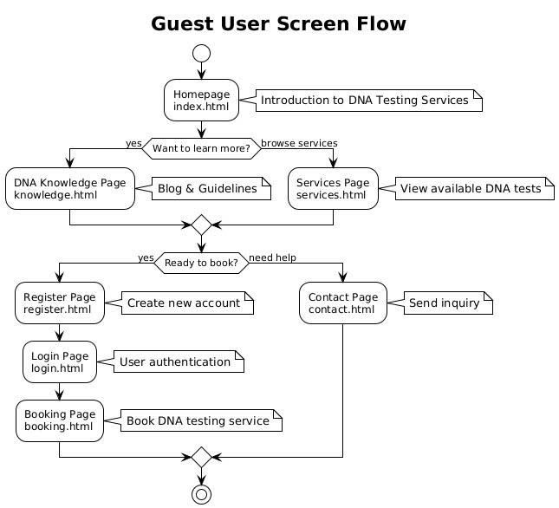

**Customer**

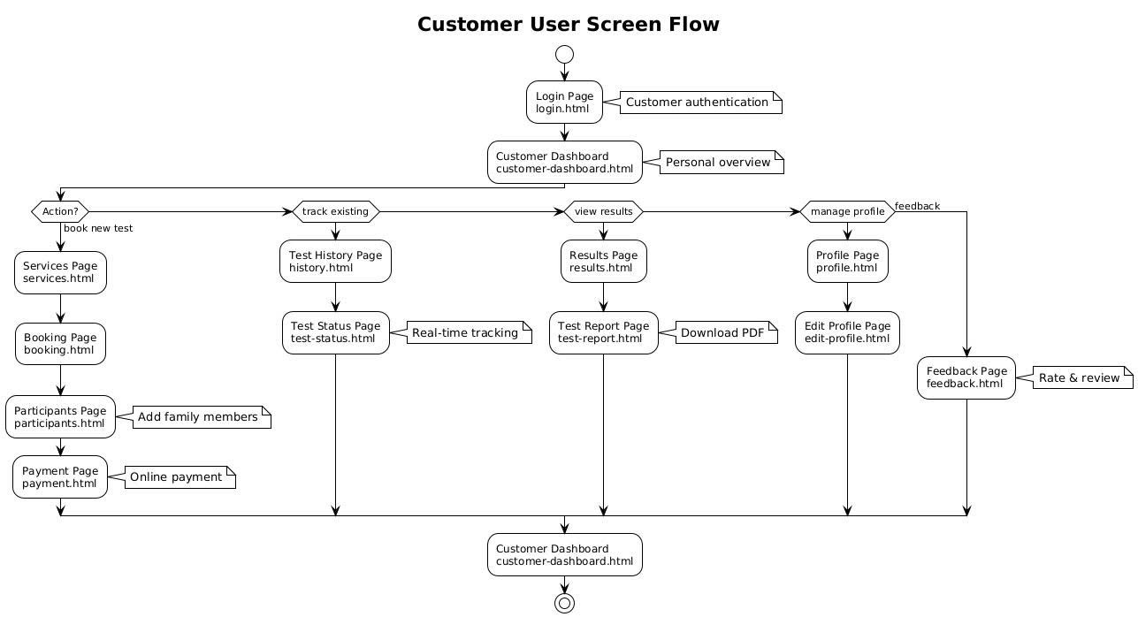

**Manager**

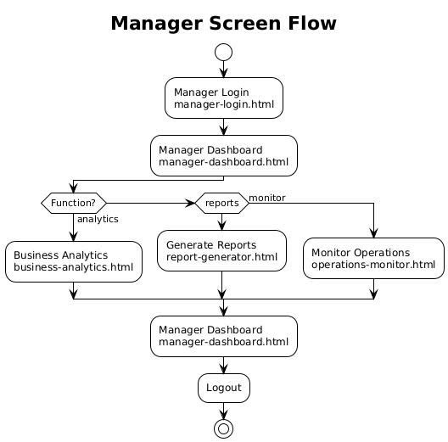

**Staff**

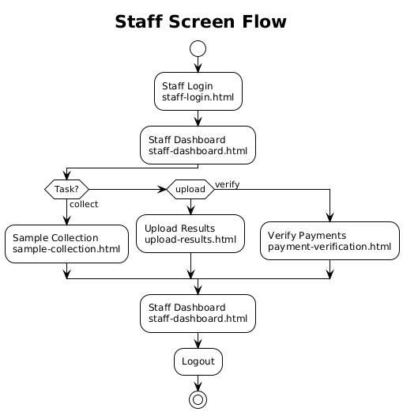

**Admin**

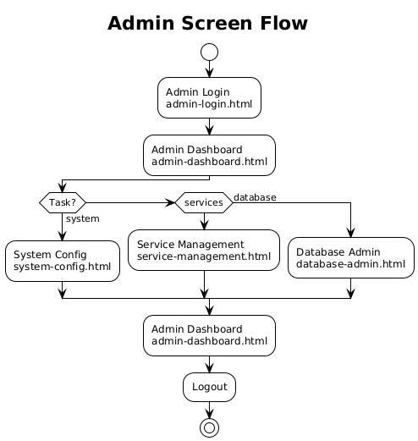

#### 4.1.2 Screen Descriptions

|  |  |  |  |
| --- | --- | --- | --- |
| **#** | **Feature** | **Screen** | **Description** |
| 1 | User Authentication | Login Page | Allows users to enter login credentials to access the system. |
| 2 | User Authentication | Register Page | Interface for guests to create a new account using personal information. |
| 3 | User Authentication | Logout | Logs the user out of the system and redirects to the home or login page. |
| 4 | Main Navigation | Home Page | Main interface for users based on their roles (Guest, Customer, Staff, Admin, Manager). |
| 5 | DNA Test Booking | Select Service and Sampling Method | Screen that allows users to choose a DNA test type and sampling method (at home or in-clinic). |
| 6 | Sample Submission | Enter Kit Info and Submit Sample | Interface where users input the DNA kit code and send sample to the medical facility. |
| 7 | In-Clinic Sample Collection | Collect Sample and Update Request | Staff collects samples and updates the test request in the system. |
| 8 | Test Result | View Test Result | Screen that allows users to view their DNA test results. |
| 9 | DNA Knowledge Blog | Blog List | Displays posts sharing DNA knowledge, test guidelines, and real user experiences. |
| 10 | Service Feedback | Submit Rating | Users submit feedback on service quality after receiving results. |
| 11 | User Profile | Manage Profile | Users update their personal information and view test history. |
| 12 | System Management | Manage Services & Pricing | Admin adds/edits DNA test types, pricing, and related information. |
| 13 | Feedback Management | Manage Feedback | Admin reviews and responds to user ratings and complaints. |
| 14 | Reporting & Analytics | Dashboard | Displays statistics on users, test orders, revenue, etc., for system administrators. |

#### 4.1.3 Screen Authorization

|  |  |  |  |  |  |
| --- | --- | --- | --- | --- | --- |
| **Screen / Activity** | **Guest** | **Customer** | **Consultant** | **Staff** | **Admin** |
| Homepage | ✅ | ✅ | ✅ | ✅ | ✅ |
| Service List & Filter | ✅ | ✅ | ✅ | ✅ | ✅ |
| Service Detail | ✅ | ✅ | ✅ | ✅ | ✅ |
| Blog List & Filter | ✅ | ✅ | ✅ | ✅ | ✅ |
| Blog Detail | ✅ | ✅ | ✅ | ✅ | ✅ |
| Register Account | ✅ | ❌ | ❌ | ❌ | ❌ |
| Login | ✅ | ✅ | ✅ | ✅ | ✅ |
| Book DNA Test | ❌ | ✅ | ❌ | ❌ | ❌ |
| View Booking History | ❌ | ✅ | ❌ | ❌ | ❌ |
| Cancel DNA Test Booking | ❌ | ✅ | ❌ | ❌ | ❌ |
| Upload Test Sample Info | ❌ | ❌ | ✅ | ✅ | ✅ |
| View Assigned Samples | ❌ | ❌ | ✅ | ✅ | ✅ |
| Input Test Result | ❌ | ❌ | ✅ | ✅ | ✅ |
| View Test Result | ❌ | ✅ | ❌ | ❌ | ❌ |
| Give Feedback | ❌ | ✅ | ❌ | ❌ | ❌ |
| View Feedback Report | ❌ | ❌ | ❌ | ✅ | ✅ |
| Manage Users | ❌ | ❌ | ❌ | ❌ | ✅ |
| View System Performance | ❌ | ❌ | ❌ | ❌ | ✅ |

#### 4.1.4 Non-Screen Functions

|  |  |  |  |
| --- | --- | --- | --- |
| **#** | **Feature** | **System Function** | **Description** |
| 1 | User Authentication | Check username/password is correct | Validate login information and create session if valid. |
|  |  | Encrypt user password | Encrypt user password before saving to database. |
| 2 | Account Management | Check user role and permissions | Check user role to grant corresponding access. |
| 3 | DNA Test Booking | Check schedule availability | Check test slot availability before confirming appointment. |
| 4 | Appointment Coordination | Auto assign available staff/consultant | Automatically assign appropriate staff based on available time and service type. |
| 5 | Result Processing | Validate input data before saving result | Check input data before saving test results to the system. |
| 6 | Feedback Collection | Accept and store feedback | Save customer feedback on service to the system for later analysis. |
| 7 | Notification System | Send email/SMS/notification | Send appointment notification, update progress and return results to customers. |
| 8 | Report Generation | Aggregate booking and feedback data | Synthesize appointment data, results and feedback to export reports to Admin. |

#### 4.1.5 Entity Relationship Diagram

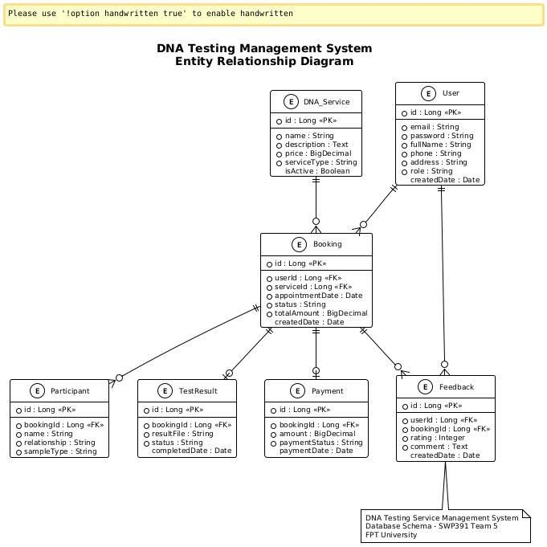

**Entities Description**

|  |  |  |
| --- | --- | --- |
| **#** | **Entity** | **Description** |
| 1 | **User Information** | Contains user profile details such as full name, email, phone number, date of birth, address, avatar, and OTP for verification and profile access. |
| 2 | **Service** | Includes health-related services such as **DNA Test (In-Facility or At-Home)**. Each service has type, description, and sample handling instructions. |
| *3* | **Submission** | Contains **TestResult** submitted by staff after processing samples. Includes sample code, test date, result date, result type (e.g., positive/negative). |
| *4* | **Content** | Stores blog posts created by admins or staff. Includes title, body content, images, and creator information. |
| *5* | **Authentication** | Stores OTP codes for login or account verification, including the code itself, creation timestamp, and expiration time. |
| *6* | **Sample Kit Handling** | Tracks at-home test kit logistics: delivery status to user, expected return date, and confirmation of kit received back for processing. |
| 7 | **System Metadata** | EFMigrationHistory stores internal database versioning information, used by Entity Framework to track schema migrations. |

## 5. Use case details

## UC-01 Login

|  |  |
| --- | --- |
| UC ID and Name | UC-02 Login |
| Primary Actor | Guest |
| Secondary Actor | None |
| Date | 29/07/2025 |
| Description | This use case allows any registered user to log into the system using google account |
| Trigger | User navigates to the login page and submits credentials. |
| Preconditions | - User has a registered account. - google are valid. |
| Post-conditions | - User is logged in and redirected to homepage or dashboard. |
| Normal Flow | 1. User opens login page. 2. Enters google account. 3. Submits the login form. 4. System validates credentials. 5. If valid, user is granted access. |
| Alternative Flows | - Incorrect credentials → Show error message. |
| Exceptions | - Server error or database issue → Show login failure. |
| Priority | High |
| Frequency | Everyday, multiple times a day. |
| Business Rules | BR-05, BR-10 |
| Mockup |  |
| Other Information | May include CAPTCHA or 2FA. |
| Assumptions | User remembers correct credentials. |

## UC-02 Book DNA Test

|  |  |
| --- | --- |
| UC ID and Name | UC-02 Book DNA Test |
| Primary Actor | Customer |
| Secondary Actor | None |
| Date | 29/07/2025 |
| Description | This use case allows a logged-in customer to book a DNA test by selecting service, date, and time. |
| Trigger | Customer clicks 'Book Test' and fills in required information. |
| Preconditions | - Customer must be logged in. - Desired time slot is available. |
| Post-conditions | - Booking is recorded in the system and confirmation is displayed. |
| Normal Flow | 1. Customer navigates to DNA test service page. 2. Selects type of DNA test and test location. 3. Chooses available date and time. 4. Confirms booking. 5. System stores booking information and displays confirmation. |
| Alternative Flows | - Selected time is no longer available → Ask to choose another slot. |
| Exceptions | - Booking service is temporarily unavailable → Show maintenance message. |
| Priority | High |
| Frequency | Occasional – depending on demand. |
| Business Rules | BR-01, BR-02, BR-11 |
| Mockup |  |
| Other Information | May support calendar integration or notifications. |
| Assumptions | Customer understands booking process. |

## UC-03 Cancel Booking

|  |  |
| --- | --- |
| UC ID and Name | UC-03 Cancel Booking |
| Primary Actor | Customer |
| Secondary Actor | None |
| Date | 29/07/2025 |
| Description | This use case allows customers to cancel their previously scheduled DNA test appointments. |
| Trigger | Customer clicks 'Cancel' on a scheduled test. |
| Preconditions | - Customer has a valid upcoming booking. |
| Post-conditions | - Booking is canceled and time slot is released. |
| Normal Flow | 1. Customer goes to booking history. 2. Selects booking to cancel. 3. Clicks 'Cancel'. 4. System asks for confirmation. 5. Customer confirms. 6. System updates booking status to canceled. |
| Alternative Flows | - Booking is too close to scheduled time → Show policy message. |
| Exceptions | - System error when canceling → Show retry option. |
| Priority | Medium |
| Frequency | Occasional |
| Business Rules | BR-12, BR-13 |
| Mockup |  |
| Other Information | Can log cancellation reasons for analysis. |
| Assumptions | Customer understands cancelation policy. |

## UC-04 View Test Result

|  |  |
| --- | --- |
| UC ID and Name | UC-04 View Test Result |
| Primary Actor | Customer |
| Secondary Actor | None |
| Date | 29/07/2025 |
| Description | This use case allows customers to view their test results once the DNA test is completed and approved. |
| Trigger | Customer logs in and navigates to results section. |
| Preconditions | - Test has been completed and results uploaded. |
| Post-conditions | - Customer can read/download result securely. |
| Normal Flow | 1. Customer logs in. 2. Navigates to 'My Results'. 3. Selects completed test. 4. System retrieves and displays result. 5. Customer downloads result if needed. |
| Alternative Flows | - Result not ready yet → Display waiting message. |
| Exceptions | - File download error → Prompt retry. |
| Priority | High |
| Frequency | Occasional – once per test. |
| Business Rules | BR-14, BR-15, BR-16 |
| Mockup |  |
| Other Information | Result file may be encrypted or password protected. |
| Assumptions | Customer understands test timeline. |

## UC-05 Manage Blog

|  |  |
| --- | --- |
| UC ID and Name | UC-05 Manage Blog |
| Primary Actor | Admin |
| Secondary Actor | None |
| Date | 29/07/2025 |
| Description | This use case allows the admin to add, edit, or delete blog posts on the system homepage. |
| Trigger | Admin navigates to the Blog Management panel. |
| Preconditions | - Admin is logged in. |
| Post-conditions | - Changes to blog content are saved and reflected publicly. |
| Normal Flow | 1. Admin logs in. 2. Goes to 'Blog Management'. 3. Adds or edits blog content. 4. Saves changes. 5. System updates blog list. |
| Alternative Flows | - Save fails due to validation → Show error. |
| Exceptions | - Database error → Log and notify admin. |
| Priority | Low |
| Frequency | Occasional – when updating content. |
| Business Rules | BR-19, BR-20 |
| Mockup |  |
| Other Information | Supports image uploads and formatting. |
| Assumptions | Admin has access rights. |

## UC-06 View Sample Collection Guide

|  |  |
| --- | --- |
| UC ID and Name | UC-06 View Sample Collection Guide |
| Primary Actor | Guest, Customer |
| Secondary Actor | None |
| Date | 29/07/2025 |
| Description | Allows users to read or view guidance on how to properly collect a DNA sample. |
| Trigger | User selects 'Sample Collection Guide' from the menu. |
| Preconditions | User has access to the system. |
| Post-conditions | Instructions are shown clearly. |
| Normal Flow | 1. User opens guide page. 2. Guide text/images are displayed. 3. User reads and exits. |
| Alternative Flows | - No alternative flow. |
| Exceptions | - Network error → Show 'Unable to load guide'. |
| Priority | Medium |
| Frequency | Often |
| Business Rules | BR-17 |
| Mockup |  |
| Other Information | Can be linked to blog section or separate static page. |
| Assumptions | Users know how to navigate to the guide section. |

## UC-07 Manage Booking Schedules (Staff)

|  |  |
| --- | --- |
| UC ID and Name | UC-07 Manage Booking Schedules (Staff) |
| Primary Actor | Staff |
| Secondary Actor | None |
| Date | 29/07/2025 |
| Description | Allows staff to view, edit, or confirm booking schedules. |
| Trigger | Staff clicks on 'Booking Schedule' page. |
| Preconditions | Staff is logged in. |
| Post-conditions | Staff can view and manage customer bookings. |
| Normal Flow | 1. Staff opens schedule page. 2. Selects date range. 3. Views booking list. 4. Updates status or adds notes. |
| Alternative Flows | - No bookings → Show empty state. |
| Exceptions | - Server error → Show message and retry option. |
| Priority | High |
| Frequency | Daily |
| Business Rules | BR-12, BR-19 |
| Mockup |  |
| Other Information | Can include filter by status/date. |
| Assumptions | Staff are trained to interpret schedule information. |

## UC-08 Manage DNA Kits (Staff)

|  |  |
| --- | --- |
| UC ID and Name | UC-08 Manage DNA Kits (Staff) |
| Primary Actor | Staff |
| Secondary Actor | None |
| Date | 29/07/2025 |
| Description | Allows staff to add, edit, and track DNA test kits. |
| Trigger | Staff navigates to the 'Kit Management' section. |
| Preconditions | Staff has permission. |
| Post-conditions | Kit info is added or updated in system. |
| Normal Flow | 1. Staff views list of kits. 2. Clicks add/edit button. 3. Submits form. 4. System updates kit list. |
| Alternative Flows | - Invalid input → Show validation error. |
| Exceptions | - Kit already exists → Prompt overwrite or cancel. |
| Priority | High |
| Frequency | Weekly |
| Business Rules | BR-23, BR-24 |
| Mockup |  |
| Other Information | May be linked to inventory system. |
| Assumptions | Staff understands types and status of kits. |

## UC-09 View My Kits (Customer)

|  |  |
| --- | --- |
| UC ID and Name | UC-09 View My Kits (Customer) |
| Primary Actor | Customer |
| Secondary Actor | None |
| Date | 29/07/2025 |
| Description | Allows customer to view list of kits sent or received, and their status. |
| Trigger | Customer selects 'My Kits' from menu. |
| Preconditions | Customer is logged in. |
| Post-conditions | Customer can track all kits. |
| Normal Flow | 1. Customer opens kit page. 2. System loads customer’s kits. 3. Displays list and statuses. |
| Alternative Flows | - No kits found → Show 'no data'. |
| Exceptions | - API failure → Show retry button. |
| Priority | Medium |
| Frequency | Monthly |
| Business Rules | BR-28 |
| Mockup |  |
| Other Information | Can show delivery and received status. |
| Assumptions | Customer understands basic status like 'In Transit', 'Used', 'Received'. |

## UC-10 Manage Test Results (Staff)

|  |  |
| --- | --- |
| UC ID and Name | UC-10 Manage Test Results (Staff) |
| Primary Actor | Staff |
| Secondary Actor | None |
| Date | 29/07/2025 |
| Description | Allows staff to upload, edit, or assign DNA test results to customers. |
| Trigger | Staff selects 'Manage Results'. |
| Preconditions | Staff has permission. |
| Post-conditions | Results are updated or assigned successfully. |
| Normal Flow | 1. Staff opens result list. 2. Clicks add/upload. 3. Selects customer/test. 4. Confirms submission. |
| Alternative Flows | - Missing attachment → Show error. |
| Exceptions | - Wrong customer ID → Show warning. |
| Priority | High |
| Frequency | Often |
| Business Rules | BR-30, BR-31 |
| Mockup |  |
| Other Information | May integrate PDF or image attachments. |
| Assumptions | Staff know how to assign results to correct customer. |

### ****6.1 External Interfaces****

#### ****6.1.1 User Interface****

* UI-1: The system must provide a user-friendly interface that is intuitive, consistent, and easy to navigate for all user roles (Guest, Customer, Consultant, Staff, Manager, Admin).
* The interface design should follow modern UX/UI best practices with accessible elements and responsive layouts for both desktop and mobile devices.
* Clear feedback should be provided for all user actions (e.g., form submissions, errors, confirmations).
* Language support must ensure that Vietnamese is consistently used across all interface elements.

#### ****6.1.2 Hardware Interface****

* No hardware interfaces are currently required.
* The system is designed to operate on standard computing environments (web browsers on PCs, laptops, smartphones, and tablets).

### ****6.2 Quality Attributes****

#### ****6.2.1 Usability****

* All texts, labels, messages, and instructions must be consistently written in Vietnamese, using simple, concise, and culturally appropriate language.
* The interface should provide tooltips or guidance for first-time users.
* Core functionalities should be accessible within no more than 3 clicks from the homepage.
* Forms must include client-side validation to give users immediate feedback before submission.

#### ****6.2.2 Reliability****

* The system is expected to operate **stably under normal conditions**, supporting basic operations such as scheduling, user data management, and result updates.
* In case of issues (e.g., invalid inputs, temporary connection loss), the system should **display clear error messages** to help users correct their actions.
* The system should be designed to **minimize critical errors**, especially in essential features like booking and viewing test results.

#### 6.2.3 Performance

* **Response Time**: The system should respond to essential user actions (such as login, booking appointments, and viewing test results) within **3–5 seconds** under normal network conditions.
* **Throughput**: The system should support at least **50 concurrent user requests** without interruption or serious degradation in performance, reflecting expected usage in a student-built environment.
* **Scalability**: While not yet deployed in large-scale production, the system design should allow for **future scaling**, such as increasing the number of users or integrating more services during peak periods (e.g., academic events, internal demo days).
* **Availability**: The system aims for an uptime of **95% or higher per month**, acknowledging potential downtime due to updates or resource constraints during student development.
* **Load Testing**: The system should be tested under simulated conditions with up to **200 concurrent users** to ensure that it remains stable and functional within the expected scope of a university project.

***6.2.4 Maintainability***

* The system should follow modular and layered architecture to simplify updates, bug fixing, and feature extensions.
* Code should follow clean code principles and be accompanied by developer documentation for easier maintenance.

***6.2.5 Portability***

* The system must be compatible with major modern browsers including Google Chrome, Mozilla Firefox, Microsoft Edge, and Safari.
* The system should be fully responsive and function properly on both desktop and mobile devices (smartphones and tablets).

## 7. Requirement Appendix

### 7.1 Business Rules

|  |  |
| --- | --- |
| **ID** | **Rule Definition** |
| BR-01 | Each time slot can be booked by only one customer. |
| BR-02 | Customers cannot book multiple services at the same time slot. |
| BR-03 | Users can only view bookings they created. |
| BR-04 | Each customer account must be unique (email must not be duplicated). |
| BR-05 | User passwords must be encrypted before being stored in the system. |
| BR-06 | Only logged-in users can make a booking. |
| BR-07 | Unverified email accounts cannot make bookings. |
| BR-08 | Booking cannot be made for past dates. |
| BR-09 | Feedback can only be submitted after test results are available. |
| BR-10 | Only customers who have used the service can leave feedback. |
| BR-11 | Staff can only view bookings assigned to them. |
| BR-12 | Admins can view all system data. |
| BR-13 | Service name cannot be empty when creating a new service. |
| BR-14 | Each test type must have at least one associated test kit. |
| BR-15 | Each test sample must be linked to a valid booking. |
| BR-16 | Test results can only be submitted once. |
| BR-17 | Only authorized staff/consultants can submit test results. |
| BR-18 | Staff are not allowed to delete customer bookings. |
| BR-19 | Completed bookings cannot be edited. |
| BR-20 | Customers can only cancel bookings at least 24 hours in advance. |
| BR-21 | Only Admins can delete user accounts. |
| BR-22 | All test samples must be recorded in the system. |
| BR-23 | Feedback data must be anonymized when generating reports. |
| BR-24 | Each blog post must belong to at least one category. |
| BR-25 | Only Admins can post and edit blog articles. |
| BR-26 | Staff working schedules must be updated before test assignments. |
| BR-27 | Confirmation emails must be sent after successful booking. |
| BR-28 | Services with existing bookings cannot be deleted. |
| BR-29 | Bookings will be auto-cancelled if no sample is received within 3 days. |
| BR-30 | Inactive users for 12 months will be temporarily deactivated. |
| BR-31 | Submitted feedback cannot be edited. |
| BR-32 | A consultant cannot handle two test samples in the same time slot. |
| BR-33 | Test results must be reviewed before being sent to the customer. |
| BR-34 | Results are only emailed if customer information has been verified. |
| BR-35 | Each booking can only be linked to one service type. |
| BR-36 | Users can have up to 3 pending bookings at the same time. |
| BR-37 | Each sample must have a unique identifier. |
| BR-38 | Sensitive data deletion must be confirmed by Admin. |
| BR-39 | All admin actions must be logged. |
| BR-40 | The system must send appointment reminders 24 hours in advance. |
| BR-41 | Consultants can only operate within their assigned permissions. |
| BR-42 | Users cannot change their own roles. |

### 7.4 Other Requirements

* **OR-01: Localization**  
  All system content, messages, and notifications must be written in **Vietnamese**, using **clear and user-friendly language** appropriate for general users.
* **OR-02: Accessibility**  
  The system **should support** features such as **font scaling** or **screen reader compatibility** to improve accessibility for users with disabilities (if time and resources allow for development).
* **OR-03: Legal Compliance**  
  The system must comply with **Vietnamese legal regulations** on the protection of personal health information (e.g., **Decree 13/2023/ND-CP on personal data protection**).
* **OR-04: Data Retention Policy**  
  User data should be retained for a **minimum of 5 years** for historical reference. Users have the right to request **permanent deletion** of their personal data upon account deactivation or service withdrawal.
* **OR-05: Third-Party Integration**  
  The system may integrate with **popular local electronic payment services** such as **Momo, ZaloPay**, or **domestic bank transfers via QR code**, if payment features are implemented.
* **OR-06: Notification System**  
  The system should support sending notifications and reminders via **email** and **in-app messages** for events such as **appointment confirmation**, **reminders**, and **test result availability**.